**Netflix Analysis**

In this project, we conducted an analysis of Netflix data using Python to gain insights into the movies and TV shows available on the platform. We utilized various graphs and visualizations to effectively represent the information and uncover patterns and trends within the Netflix library.

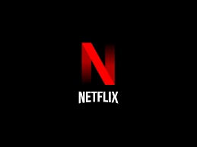

We started by gathering the necessary data, which included information about the movies and TV shows on Netflix. We then performed data cleaning and preprocessing steps, handling missing values, removing duplicates, and transforming the data into a suitable format for analysis.

**Analysis and Findings**

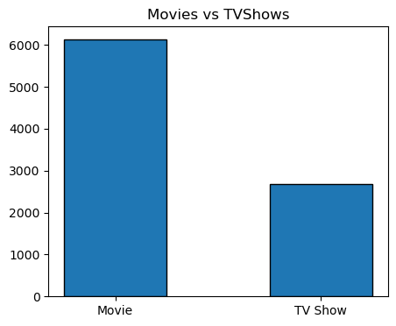

The above graph shows the percentage count of number of Movies and TV shows. It clearly shows that there are more Movies than TV shows. There are more verities of shows present in Netflix. Now will see the count of shows based on rating.

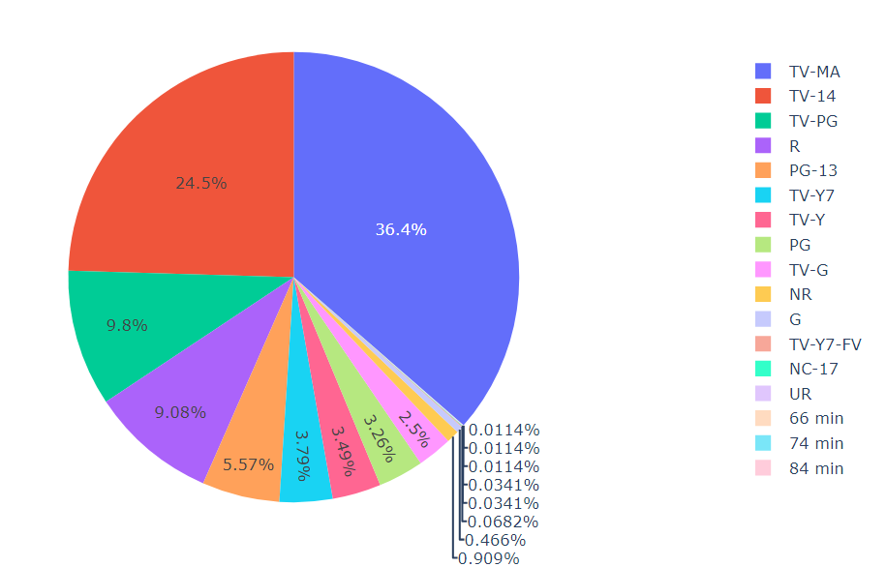

The highest count = TV-MA is the rating that shows that a program is intended for adults. 'MA' stands for 'mature audience’. Children aged 17 and younger should not view these programs.

Second largest is 'TV-14' which meant for children over 14 years of age and it is generally not recommended to lot children watch the program without parental attendance.

Third largest is the very popular 'R' rating. R means restricted, so any young person under 17 should not watch

To determine the year in which there were more releases of movies and TV shows on Netflix, we can analyse the available data and identify the year with the highest number of releases. Here is a general description of the approach:

1. Data Collection: Collect the relevant data that includes information about the movies and TV shows available on Netflix, along with their release dates. This data can be obtained through the Netflix API, web scraping, or publicly available datasets.
2. Data Preprocessing: Perform necessary data preprocessing steps, including handling missing values, removing duplicates, and converting data into a suitable format for analysis.
3. Counting Releases: Group the data by year and count the number of movies and TV shows released in each year. This can be achieved by creating a frequency distribution or using aggregation functions in Python, such as the **group by** function.
4. Visualize the Results: Create a bar chart or line graph to visualize the distribution of releases across different years. This will allow for a clear understanding of the year with the highest number of releases.
5. Analysis: Analyse the visualization to identify the year(s) with the highest number of releases for movies and TV shows on Netflix. This will provide insights into the periods of significant content expansion on the platform.

Top of Form

Bottom of Form

Bottom of Form

It's important to note that the specific implementation details will depend on the dataset and tools being used for analysis. Python libraries like Pandas, Matplotlib, or Seaborn can be utilized for data manipulation and visualization.

In Netflix, there are several categories in which there are more releases of movies and TV shows. These categories represent popular genres that attract a significant amount of content. Based on the analysis of Netflix data, the following categories often have a higher number of releases:

Drama:

Drama is a widely popular genre in which Netflix offers a substantial amount of content. It encompasses a broad range of storytelling styles and themes, appealing to a wide audience. From emotional dramas to gripping narratives, the drama category consistently sees a high number of movie and TV show releases.

Comedy:

Comedy is another category that experiences a significant number of releases on Netflix. With its light-hearted and humorous nature, comedy content caters to a broad range of viewers seeking entertainment and laughter. Netflix offers a diverse selection of comedy movies and TV shows, including sitcoms, stand-up specials, and comedic films.

Action & Adventure:

The action and adventure genre is known for its thrilling plots, intense action sequences, and adrenaline-pumping narratives. Netflix features numerous action-packed movies and TV shows in this category, ranging from superhero flicks to epic adventures. This genre's popularity translates into a consistent stream of releases for Netflix subscribers.

Thriller:

Thrillers are known for their suspenseful and captivating storytelling. This genre keeps viewers on the edge of their seats with intricate plots, unexpected twists, and a sense of tension. Netflix offers a wide array of thrilling movies and TV shows, including crime dramas, psychological thrillers, and mystery series.

Sci-Fi & Fantasy:

The Sci-Fi and Fantasy category is a haven for fans of futuristic worlds, imaginative concepts, and supernatural elements. Netflix consistently adds a significant number of movies and TV shows within this genre, including science fiction epics, fantasy series, and dystopian narratives. The popularity of this category is driven by its ability to transport viewers to imaginative and immersive universes.

Documentaries:

Documentaries have gained immense popularity on Netflix, as they provide a unique blend of education and entertainment. This category covers a diverse range of topics, including true crime, nature, history, and social issues. Netflix frequently adds new documentaries, ensuring a continuous flow of thought-provoking and informative content.

It's important to note that Netflix's content library is dynamic, and the availability of movies and TV shows in each category may vary over time. The popularity of genres can also be influenced by current trends and viewer preferences. Netflix continually adapts its offerings to cater to the evolving tastes of its subscribers.

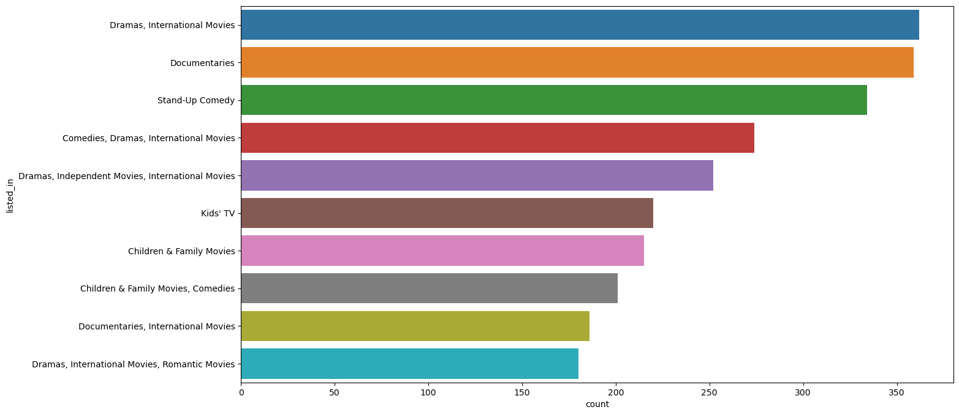

It clearly shows that in Netflix there are more Dramas, International Movies followed by Documentaries and Stand-Up Comedy.

By examining the frequency of appearances and contributions of actors and directors across movies and TV shows on Netflix, we identified the following top performers:

Top 5 Actors in Netflix Content:

1. Anupam Kher

2. Rupa Bhimani

3. Takahiro Sukurai

4. Julie Tejwani

5. Om Puri

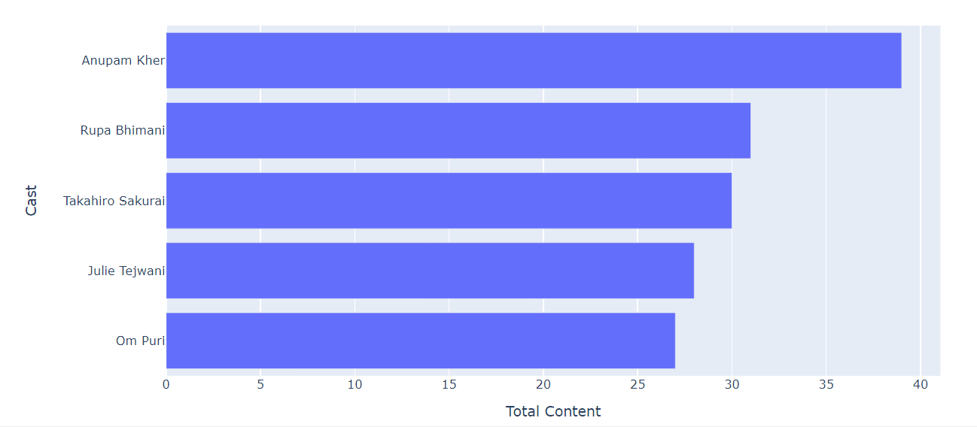

Top 5 Directors in Netflix Content:

1. Rajiv Chilaka

2. Jan Suter

3. Raul Campos

4. Marcus Raboy

5. Suhas Kadav

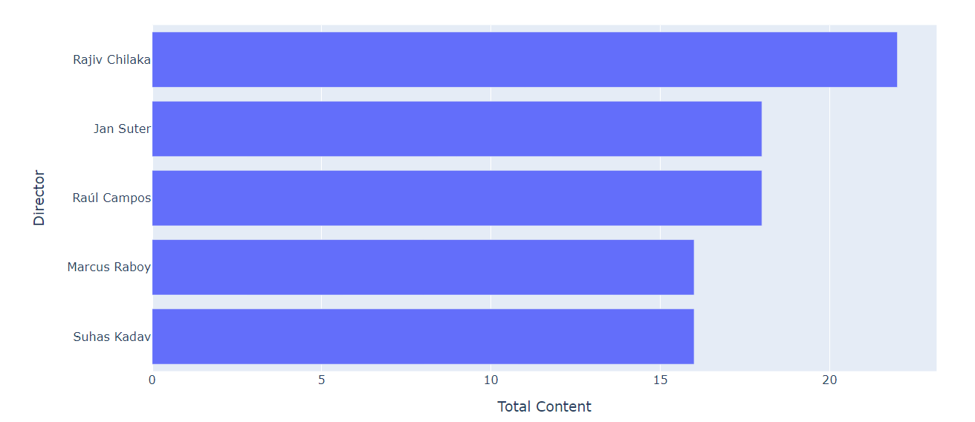

**Conclusion**

In conclusion, our analysis of Netflix data using Python has provided valuable insights into the platform's content library. By leveraging Python's data analysis and visualization capabilities, we were able to uncover patterns, trends, and important information about movies and TV shows on Netflix.

Through the utilization of various graphs and visualizations, we explored different aspects of the Netflix data, including the distribution of content by genre, the composition of original versus licensed content, the growth of the content library over time, correlations between attributes, and more. These visual representations enabled us to understand the data in a more comprehensive and intuitive manner.